**PROGRAMMING 3C**

**PROG7313**

**POE PART 1: design document**

**Group Members:**

Khatija Moosa Amod – ST10258766

Atiyyah Moola – ST10053786

Yashna Komla – ST10202387

Aisha Bilal Jakhura – ST10268917

**Part 1 – Planning and Design:**

* **Introduction**

A budgeting app is an app that helps users track their spending, set savings goals, and gain a clear understanding of where their money is going. Flourish is a budgeting app designed to integrate the best features from leading financial management apps, offering users a comprehensive and user-friendly way to track their finances. Inspired by successful apps like YNAB, TimelyBills and MoneyTracker, Flourish goes beyond basic expense tracking by incorporating gamification, automated spending insights, and interactive financial literacy tools. By combining these features, Flourish aims to provide a seamless and efficient budgeting experience.

The design of Flourish reflects the insights gained from our research, ensuring that users can manage their finances with ease. The app will include clear navigation and have a clean and user-friendly UI. The following sections outline the detailed design, including requirements, mock-ups, navigation flow, and the project plan.

* **App Overview**

**App Name:** Flourish

**App Slogan:** “Grow Your Finances, Secure Your Future”

**Icon design:**

(OpenAI, 2024).

**Description of the innovative features we are planning to include:**

Flourish introduces a range of innovative features designed to make budgeting more efficient, accessible, and user-friendly. Users will receive real-time notifications for bill reminders, transaction updates, helping them stay on top of their finances. The app supports multiple currencies, allowing users to switch between them seamlessly—a key advantage for frequent travellers or those managing international transactions.

To enhance financial knowledge, Flourish integrates multimedia financial literacy resources, including articles, videos, and podcasts, ensuring accessibility for different learning styles. A built-in calculator with advanced functions will allow users to perform calculations before logging expenses, making budgeting more accurate. Additionally, users can download detailed statements for specific time periods, making it easier to track spending trends.

Flourish also supports multiple accounts, enabling users to manage different financial aspects—such as savings, loans, and investments—all in one place. Lastly, a dedicated currency exchange page provides live exchange rates, simplifying international financial planning. By combining these features, Flourish offers a powerful, all-in-one budgeting tool that adapts to users’ financial needs.

* **List of Requirements**
* **User Registration & Authentication**
* Users must be able to create an account or login if they already have an account. Users should have the option of logging in with Facebook or Gmail.
* Secure password encryption and two-factor authentication (2FA) should be implemented to enhance security (OpenAI, 2024).
* Users should be able to reset their password.
* **Dashboard & Overview**
* Upon logging in, users should be greeted with a dashboard displaying their current financial status, including:
  + Total balance across accounts
  + Monthly budget summary
  + Upcoming bills and reminders
  + Recent transactions
* **Expense & Income Tracking**
* Users must be able to log income and expenses manually.
* Each transaction should include:
  + Amount
  + Category (e.g., food, rent, entertainment)
  + Description
  + Payment method (cash, credit, bank transfer)
  + Date and time
  + Notes (optional)
  + Photo attachment e.g., a receipt.(optional)
* **Budgeting Tools**
* Users can set monthly budgets for different categories (e.g., groceries, rent).
* The app should provide visual progress indicators (e.g., progress bars, pie charts) to show spending against the budget.
* Users should receive alerts when they are close to exceeding their budget in a specific category.
* **Notifications**
* The app must send reminders for:
  + Upcoming bill payments
  + Monthly budget updates
  + Transaction confirmations
  + Overdue payments
* **Multi-Currency Support**
* Users can select a default currency upon signup.
* Transactions can be recorded in multiple currencies, with real-time conversion based on live exchange rates.
* A currency selector should be available when adding expenses.
* **Financial Literacy Resources**
* A dedicated learning hub with articles, videos, and podcasts to educate users on financial management.
* Content should be categorized into media type e.g. Videos, articles and podcasts.
* Accessibility features can be included, such as text-to-speech for articles and closed captions for videos.
* **Built-in Calculator**
* A multi-functional calculator should be integrated within the app to allow users to perform various calculations beyond mere addition and subtraction.
* **Statement & Report Downloading**
* Users should be able to download monthly statements in PDF format.
* Statements should include:
  + A breakdown of income, expenses, and savings.
  + Graphs or visual insights on spending trends.
  + Custom date range selection.
* **Multiple Accounts Management**
* Users can create and manage multiple financial accounts (e.g., personal, business, savings).
* Each account should have:
  + Its own transaction history.
  + The ability to set specific budgets.
  + Separate currency options.
* **Live Currency Exchange Page**
* A currency exchange page should display real-time exchange rates.
* Users should be able to convert amounts between different currencies instantly.
* **Navigation & Accessibility**
* The app should have an intuitive layout with easy access to all features.
* Dark mode and light mode should be available.
* The app must be accessible for users with disabilities, including:
  + Screen reader compatibility.
  + Colorblind-friendly UI design.

(OpenAI, 2024).

* **Gamification Elements**
* Users earn achievement badges for reaching budgeting goals.
* A streak system rewards users for consistent expense tracking.
* Leaderboard challenges for users who wish to participate in budgeting goals with friends (optional nice-to-have feature) (OpenAI, 2024).
* **Platform Compatibility**
* The app should be available for Android mobile devices.
* **Development Timeline**
* The project must be completed within the planned milestones (detailed in the Gantt chart).
* **Testing & Quality Assurance**
* Conduct thorough unit testing and user testing before launch.
* Ensure the app functions smoothly on different screen sizes and operating systems.
* **User Interface Design**

Link to Figma mockup design: <https://www.figma.com/design/kD821c0gfim4x5X9d47zvt/Flourish?node-id=0-1&t=G1a6OL6XK6wEUnWZ-1>

(Figma, 2024a).

**Launch Screen 1**

This screen is the first screen that is displayed when entering our app. It displays our app name and our logo. The user must click the “Get Started” button to enter the app.

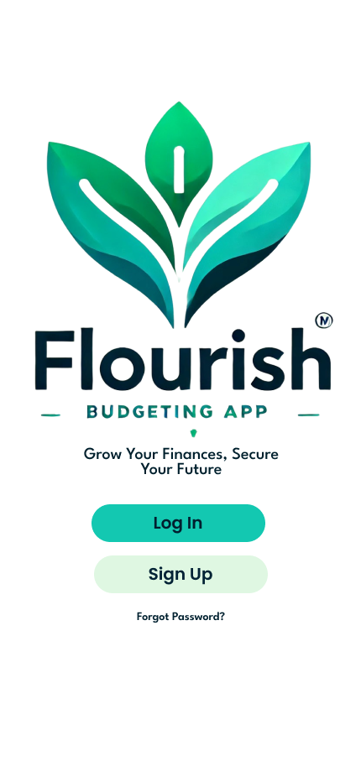

(Figma, 2024a).

**Launch Screen 2**

After the user clicks the “Get Started” button it takes them to launch screen 2. This displays the Flourish logo as well the Flourish slogan which is “Grow Your Finances, Secure Your Future”. This screen is where the user can click the “sign up” button if it is their first time using the app or alternatively the user can click the “log in” button if they already have an account.

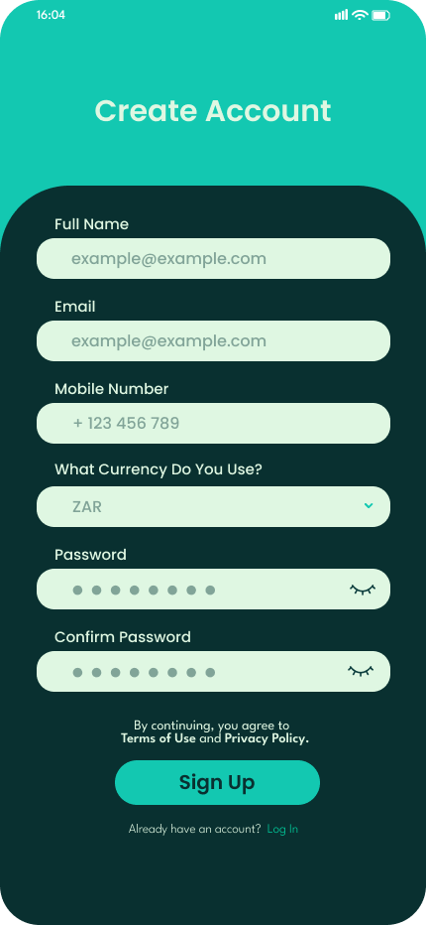

(Figma, 2024a).

**Sign Up Screen**

User authentication is the main emphasis of this part, which enables new users to register credentials and sign up. This screen allows a user to create an account using their email and password which will be their log in details. It allows the user to select the currency that they want to work with. Due to security concerns, the password cannot be seen unless you tap the eye. After the user fills in all the fields which are not optional fields, they can click the sign up button. If the use already has an account but is on this screen, they can app “Already have an account? Log in” which will redirect them to the login page.

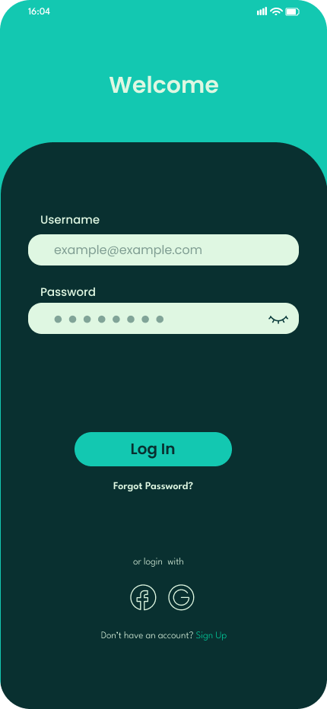

(Figma, 2024a)

**Login Screen**

User authorization confirms the identity of the user and allows entrance to the application. This screen allows a user to log into their account using their email and password. Alternatively, it allows them to login into the app with their Facebook and google account by tapping the respective symbols. If they on the login screen and they don’t have an account, they can click “Don't have an account? Sign Up” which will redirect them to the Sign-Up page.

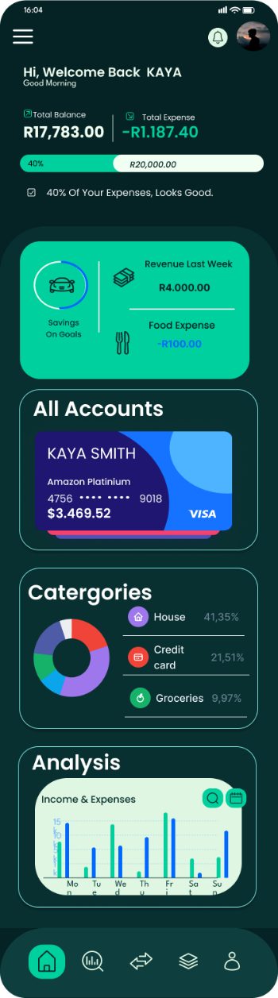 (Figma, 2024a).

**Home Screen**

Once the user is logged in, it will redirect them to the Home screen. The home screen is made up for different aspects. It essentially provides quick access to all the features of the app.

It displays the budget, recent expenses and a bar as a visual aid of the budget.

It provides widgets where the user can view their goal progress, recent expenses, recent charts, accounts and analysis. The user must tap the widget and it will take to the necessary page alternatively they can use the navbar or menu.

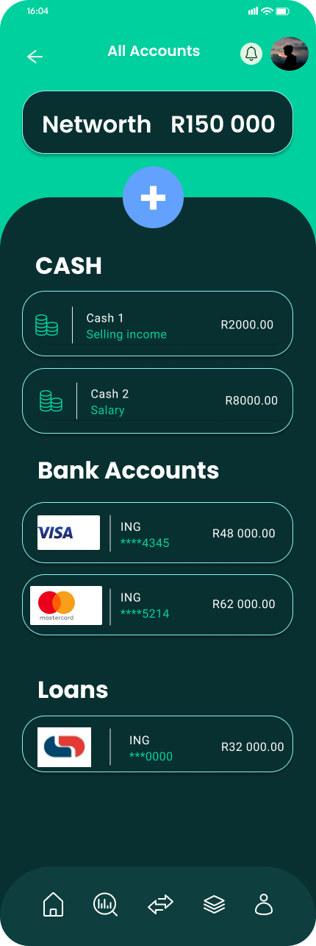 (Figma, 2024a, Figma, 2024b)

**All Accounts Screen**

If the user clicks on the all accounts widget on the home dashboard, it will redirect the user to the All Accounts page. Here it displays their Net Worth, cash, bank accounts, loans and investments with the details pertaining to each account and the amounts within it. The user can select any of the accounts to view more information and the latest transactions. If the user clicks the plus button, they will be able to add an account.

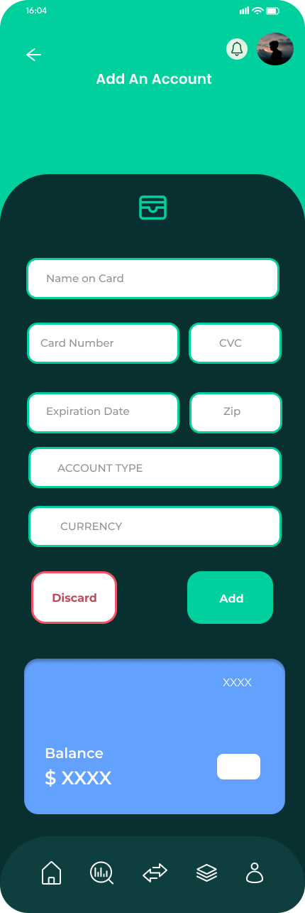 (Figma, 2024a, Figma, 2024b)

**Add an account Screen**

This is where a user can add an account by adding the card name, number, account type and currency . The two distinctive buttons allow users to add to add or discard the card. This process makes it quick and simple for users to add accounts in order to monitor them.

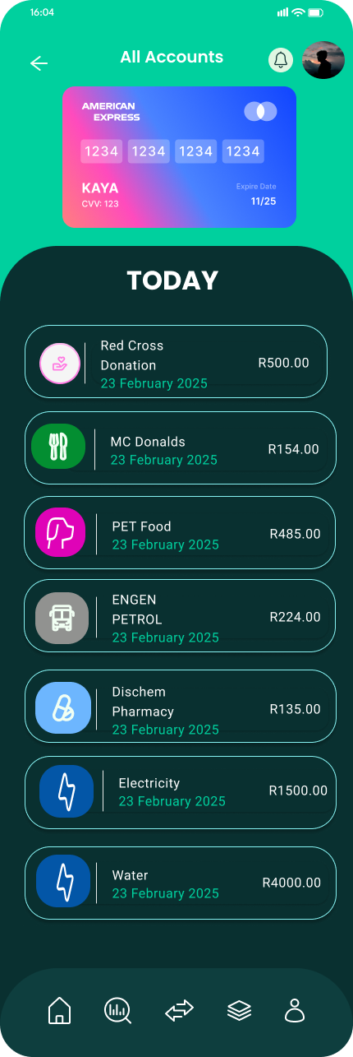 (Figma, 2024a, Figma, 2024)

**Transactions on an account screen**

If the user clicks on an account, it will take them to this screen and show them all the latest transactions on this account. If the user clicks the arrow they can go back to the previous page.

 (Figma, 2024a )

**The Navbar**

The navbar allows users to move through screens with ease. The house icon on the navbar allows users to go to the Home Dashboard. The search icon with stats inside allows users to access the Analysis screen where they can view charts etc. The two arrows redirect users to the Transactions screen where they can view all Transactions and their Budget. The multiple squares icon allows users to go to the category screen where they can view the categories and finally the person icon allows users to view their profile.

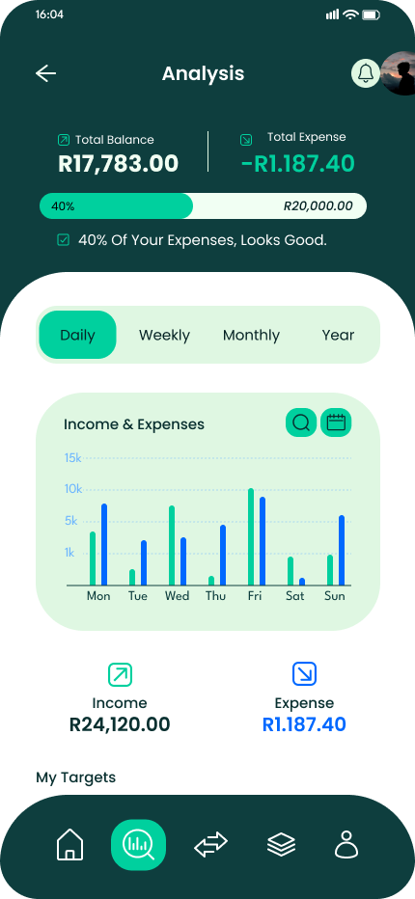 (Figma, 2024a)

**Analysis (Daily)**

On this screen you can see your balances and expenses. You can view your income and expenses during difference user selectable periods. In this case, on the screen is the income and expenses daily which has been compared to each other on a bar graph allowing the user to fully understand the differences between income and expenses.

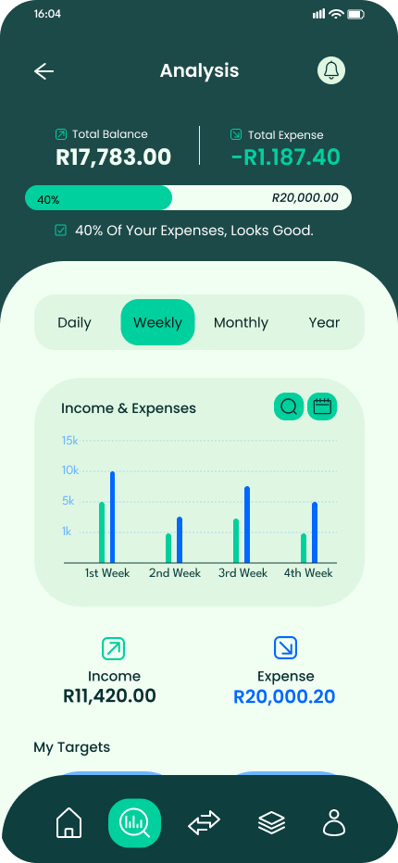 (Figma, 2024a)

**Analysis (Weekly)**

The user can click onto weekly and the screens will change to show the analysis of income vs expenses on a weekly basis. On this screen you can see all the income and expenses for one week compared to each other and to the other weeks. This allows a user to understand how to budget as you can see in the bar graph, the users expense are higher than the weekly income.

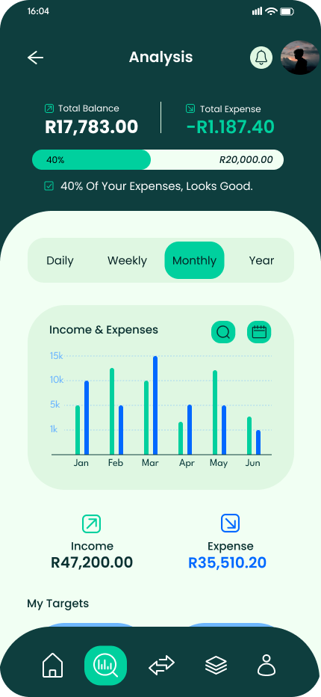 (Figma, 2024a)

**Analysis (Monthly)**

The user can click onto monthly and the screens will change to show the analysis of income vs expenses on a monthly basis. On this screen you will see all the income and expenses for one month compared to each other and to the other months. These graphical insights allow a user to understand how to budget.

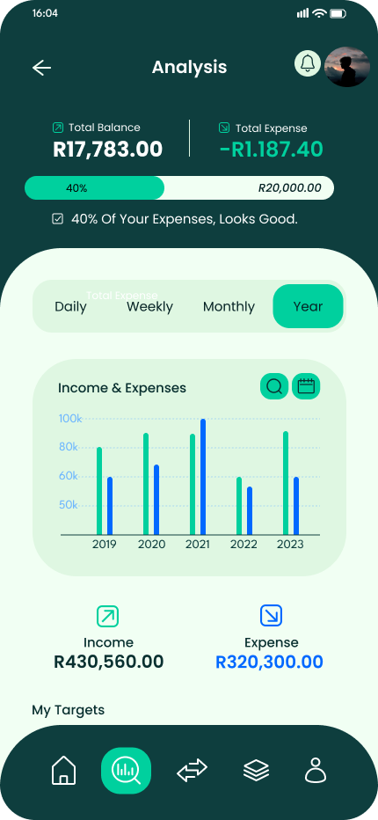 (Figma, 2024a)

**Analysis (Yearly)**

The user can click onto yearly and the screens will change to show the analysis of income vs expenses on a yearly basis. On this screen you can see all the income and expenses for one year compared to each other and to the other years.

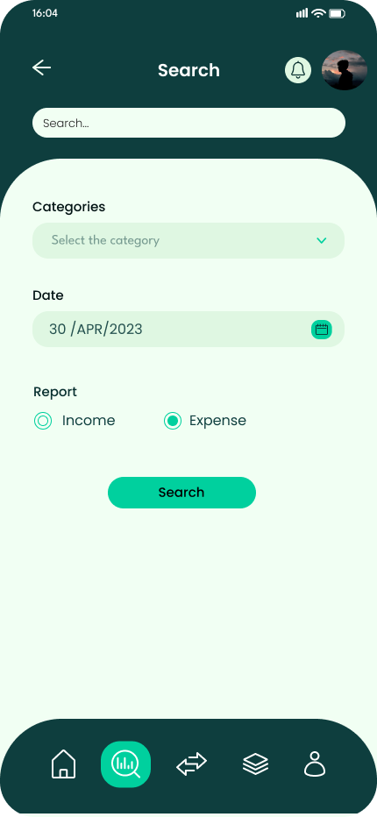 (Figma, 2024a)

**Search Screen 1**

If the user selects the search icon on the graph from the previous screen, it redirects them to this screen .The search screen allows users to filter and locate specific transactions based on categories, dates, and income/expense type. Users can type in keywords to find transactions in the search bar. Users can choose a specific date to refine results. It has a category drop down allowing Allows filtering by specific spending categories. Users can toggle between "Income" and "Expense" filters. The user can press the search button which will display the results.

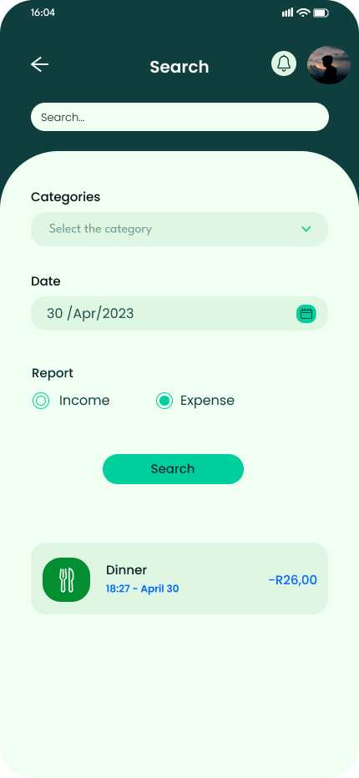 (Figma, 2024a)

**Search Screen 2**

If the user selects the search button then this screen will show . This screen is a more detailed version of the Search screen, displaying actual search results from the user's transaction history. It contains the same features as the screen above.

It shows transaction results and displays a list of matching transactions such as Category Icon & Name (e.g., Dinner, Transport, etc.), Date & Time of Transaction and Expense Amount.

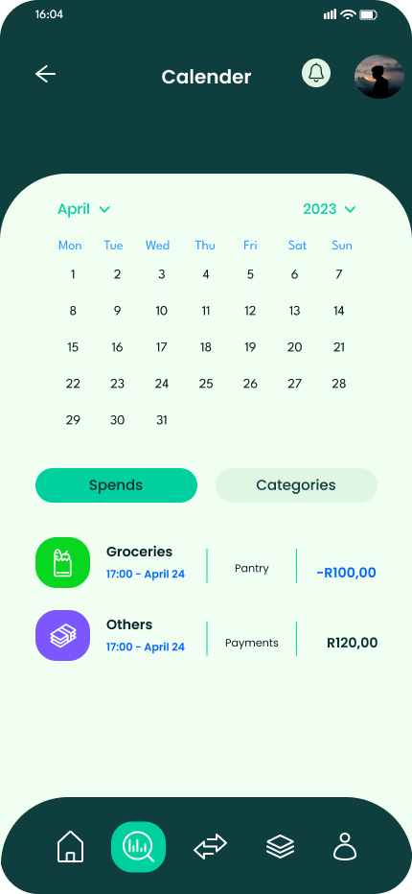 ( Figma, 2024a)

**Calendar Screen 1**

If the user selects the calendar icon button then this screen will display . This screen provides a calendar view of the user’s expenses and spending patterns over a selected month. It allows users to analyze their financial habits through a visual representation of expenses categorized into different spending groups. Users can choose a specific month and year to view historical data. The calendar displays the full month with interactive dates. Below the calendar, there are two tabs:

* Spends Tab: Displays a breakdown of spending trends.
* Categories Tab: Shows spending distribution across different categories in a pie chart.

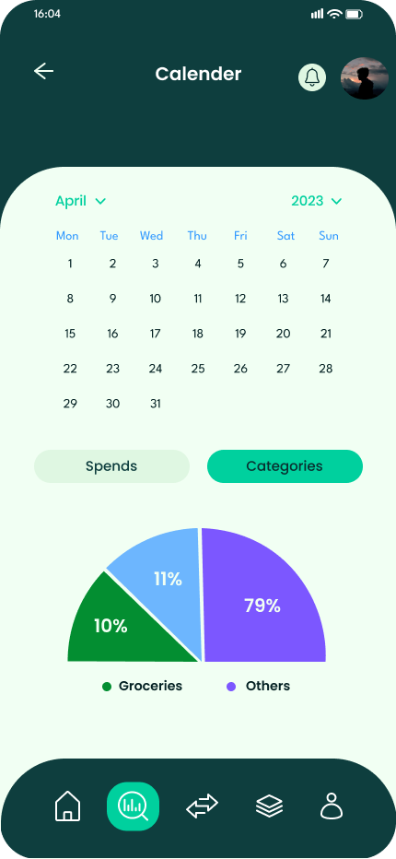(Figma, 2024a)

**Calendar Screen 2**

If the user selects the categories button then this screen will display . This screen is used to show all detailed spending transactions rather than category visualization. This screen uses a pie chart to help users quickly understand where most of their money is being spent. Instead of just a pie chart, users can see individual expenses for selected dates which breakdown their spending habits.

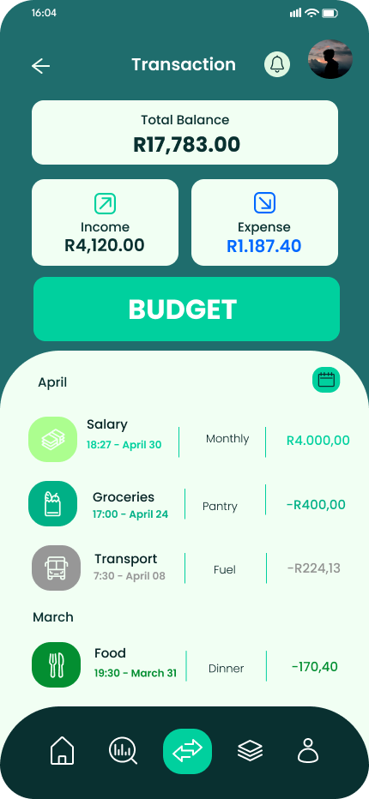 (Figma, 2024a)

**Transaction Screen 1**

If the user selects the two arrows on the navbar , it will redirect them to this screen which is the transaction screen. This allows the user to filter transactions based on income or expense. It displays all categories, descriptions and the amounts. There's also a Budget button which allow them to be redirected to the budget dashboard screen.

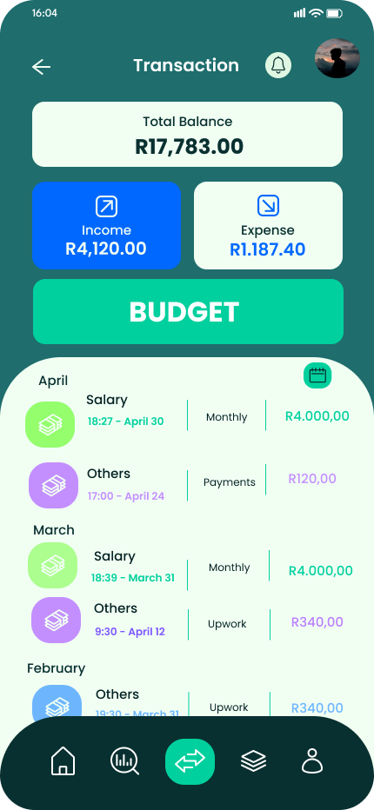 (Figma, 2024a)

**Transaction Screen 2 ( Income)**

If the user selects the income button on the main screen then all the income transactions starting from current month to previous months will be displayed. This will show all categories, description and amounts. This allows the user to understand better all income transactions.

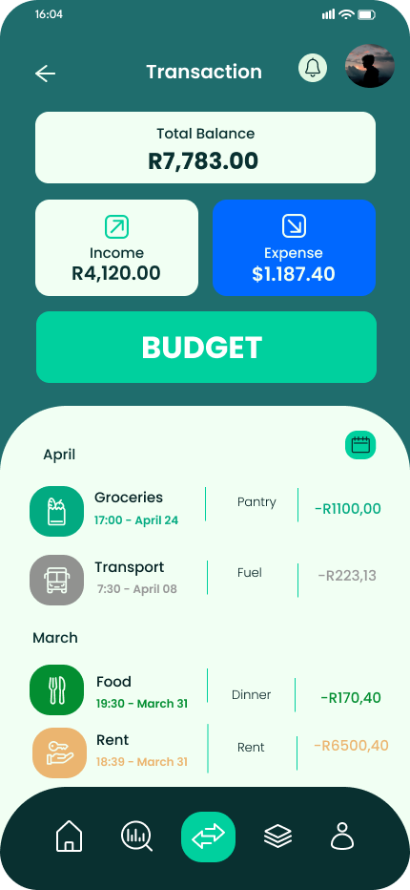 (Figma, 2024a)

**Transaction Screen 3 ( Expense)**

If the user selects the expense button on the screen, then all the expense transactions starting from the current month to previous months will be displayed. This will show all categories, description and amounts. This allows the user to understand all expense transactions.

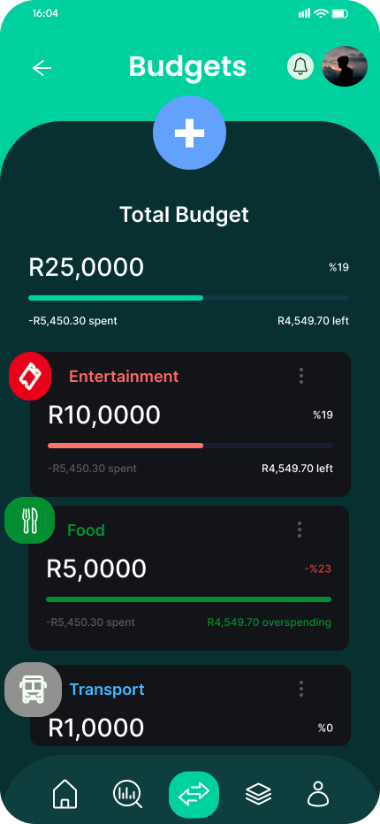 (Figma, 2024a, Figma, 2024b )

**Budget Dashboard**

If the user selects the budget button on the main transaction screen, then it will redirect them to the budget dashboard screen. This shows a plus button which allows users to create budgets. It shows a progress bar to indicate how much of the total budget has been spent and how much is still available to spend. Thereafter it shows the progress bar per category allowing users to understand weather they using their budget or overspending.

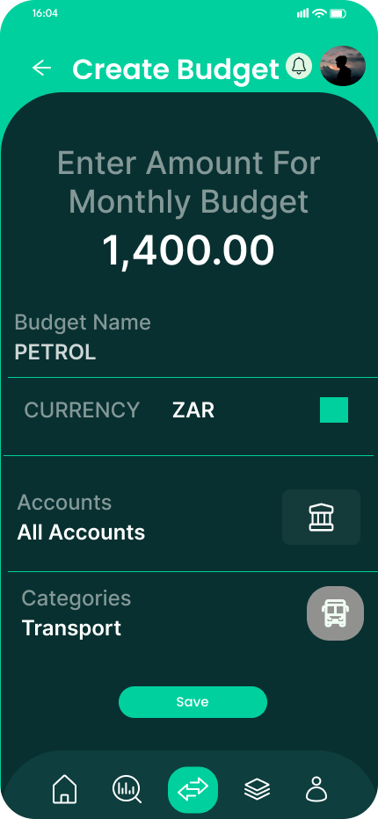 (Figma, 2024a, Figma, 2024b)

**Create Budget Screen**

If the user selects the plus button on the budget dashboard screen, then it will redirect them to the create budget screen. This screen allows users to enter a budget name, choose their currency via a dropdown menu, choose which account they would like to link to this specific budget as well a category . If the user presses the save budget, then it will save the budget.

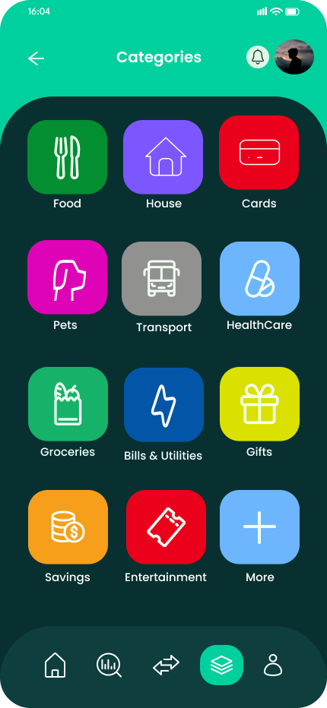 (Figma, 2024a)

**Categories Screen**

If the user selects the squares stacked on top of each other on the navbar it will redirect the screen to the categories screen. A user can view all categories and add more by pressing the category tab with the plus on it. The user can select a category, and it will take them to a different screen where they can view transactions based on that category.

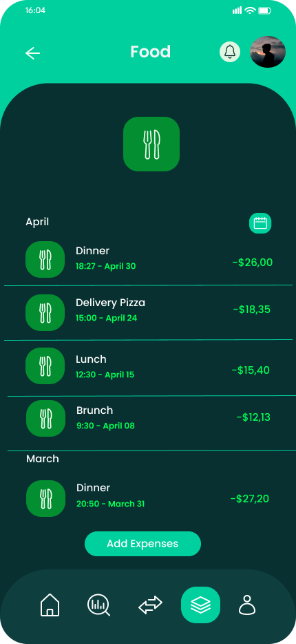 (Figma, 2024a)

**Food Category Screen**

If the user selects a category in this example food, then it redirects them to this screen where they can see all the transactions based on that category. If they want to add an expense, then they can press the add expense which will allow them to add an expense for the category food.

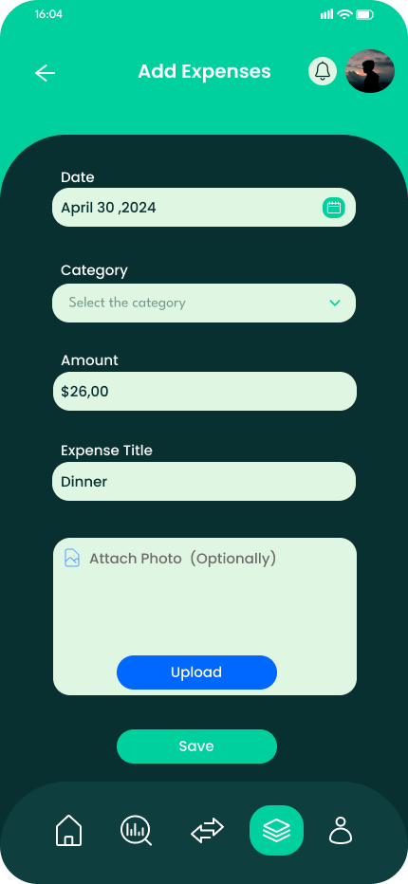 (Figma, 2024a)

**Add an Expense Screen**

If the user selects the add expense button , it will redirect them to this screen. The user can enter the date, select a category from the from down menu, enter the amount and expense title. Users can attach a photo optionally of a receipt to keep track of expenses or for tax purposes. Once you can upload the photo by pressing the button upload and then save the expense entry by pressing the button save.

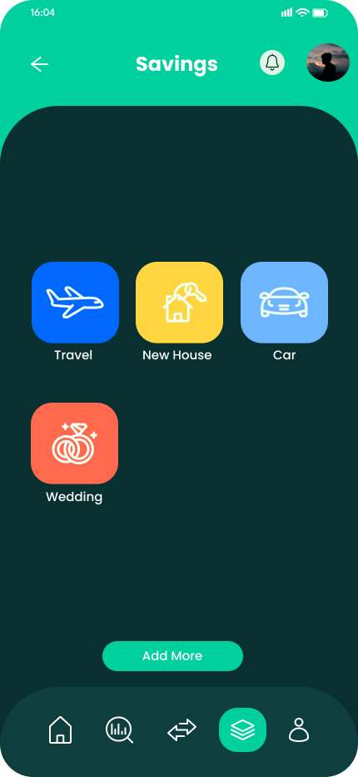 (Figma, 2024a)

**Savings Screen**

When the user selects the "Savings" button from the main category page, they will be redirected to this screen. Here, they can view all the savings goals they’ve set. By tapping on any goal, the user can access detailed information and view associated transactions. Additionally, the user can easily add new goals by pressing the "Add More" button.

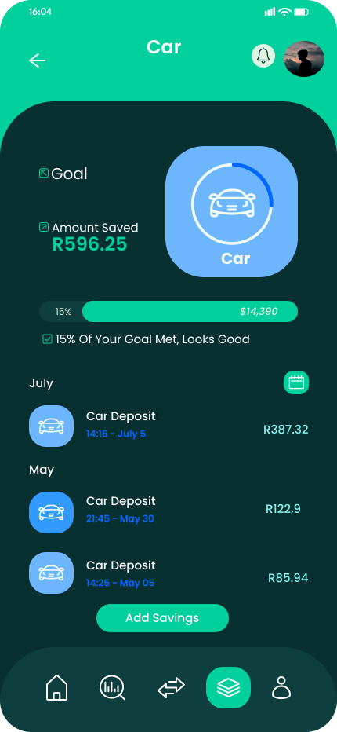 (Figma, 2024a)

**Car Savings Screen**

When the user selects the car icon from the main screen, they are redirected to this screen, which provides a clear overview of their savings progress for this goal. A progress bar with an elliptical indicator around the car icon visually represents how much they have saved so far. Below the progress bar, a detailed list of all transactions related to this savings goal is displayed. If the user taps the "Add Savings" button, they can quickly record a new savings entry, making it easy to track and manage their financial goals effectively.

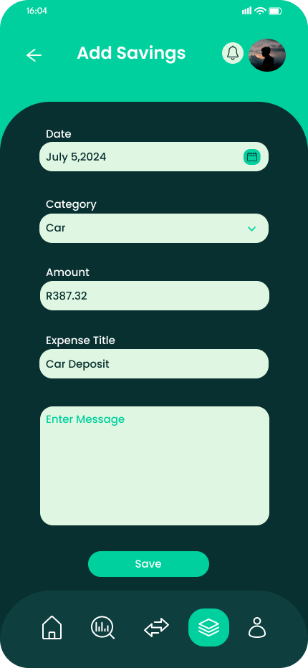 (Figma, 2024a)

**Add Savings Screen**

Here, users can select a date, choose a savings category (such as a car, wedding, or emergency fund), enter the amount they wish to save, and add a custom message or description for reference. Once all fields are completed, they can simply tap the "Save" button to record their entry. This feature helps users organize their savings goals efficiently and keep track of their progress.

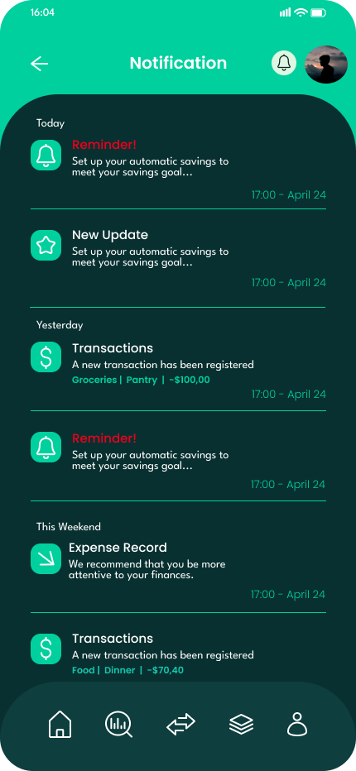 (Figma, 2024a)

**Notification Screen**

Tapping the bell icon on any screen redirects users to the Notifications page, where they can stay updated on important financial activities. Each notification is time-stamped.

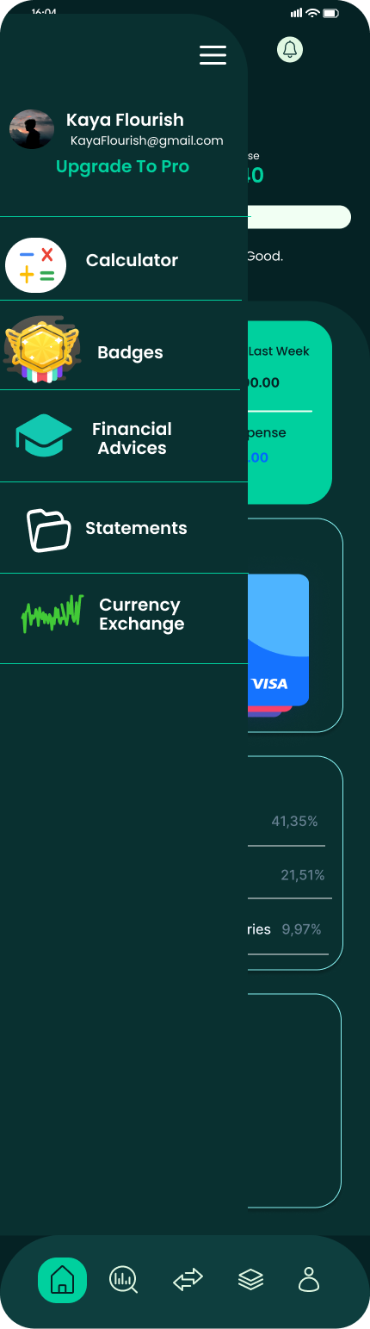 (Figma, 2025)

**The Menu Screen**

The menu provides users with seamless navigation between the app’s core and innovative features. By simply tapping the three-line icon in the top-left corner of the home screen, the menu slides open, displaying easy-to-recognize icons for quick access to key features.

These include:

* Built-in Calculator – Perform quick financial calculations.
* Badges – Track achievements and progress.
* Financial Advice – Access tips, articles, and insights.
* Currency Exchange – View real-time exchange rates

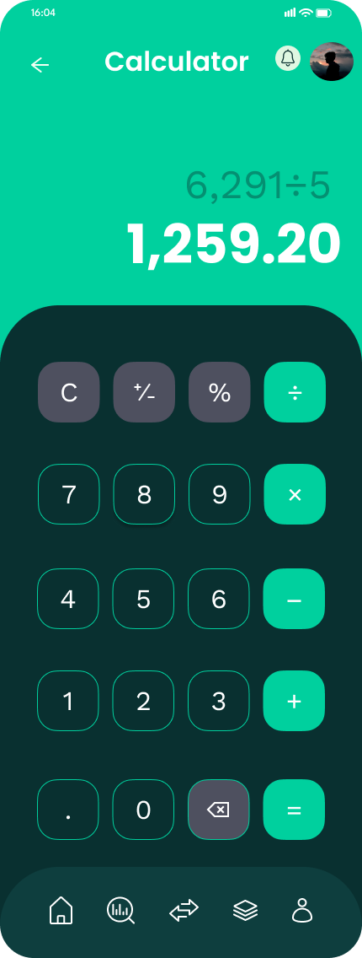 (Figma, 2024a, Figma, 2024c)

**Calculator Screen**

If users select the calculator from the menu, they will be redirected to the built-in calculator. This simple yet effective tool allows quick financial calculations before adding transactions, ensuring accuracy in budgeting, expenses, and savings. It supports basic arithmetic functions (addition, subtraction, multiplication, and division), allowing users to calculate amounts seamlessly without leaving the app.

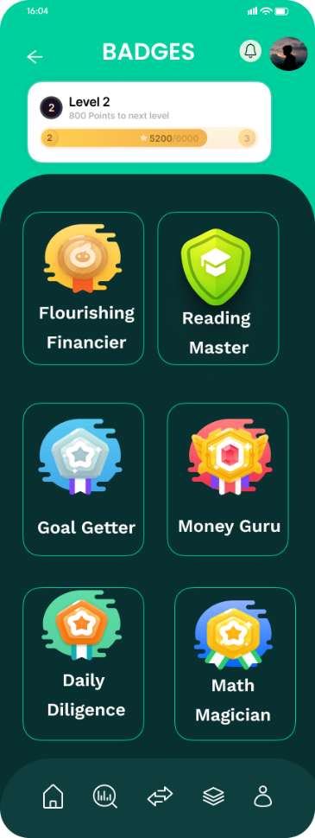 (Figma, 2024a, Figma, 2024d)

**Badges Screen**

* When the user selects "Badges" from the menu, they will be redirected to this screen. At the top, a progress bar visually represents their current level and XP (experience points) earned. Below the progress bar, users can see the badges they have unlocked, each recognizing different financial achievements.
* Some of the badges include:
* Flourishing Financier – Awarded for consistently maintaining a balanced budget and making smart financial decisions.
* Reading Master – Earned by engaging with financial literacy content like articles, videos, or podcasts.
* Goal Getter – Given when users successfully reach their savings or budgeting goals.
* Money Guru – Achieved for mastering different aspects of financial management, such as tracking expenses or setting up multiple accounts.
* Daily Diligence – Rewarded for regularly logging expenses and checking their budget every day.
* Math Magician – Earned for frequently using the built-in calculator to manage finances effectively.
* This feature gamifies financial management, keeping users motivated and engaged as they work towards better budgeting habits.

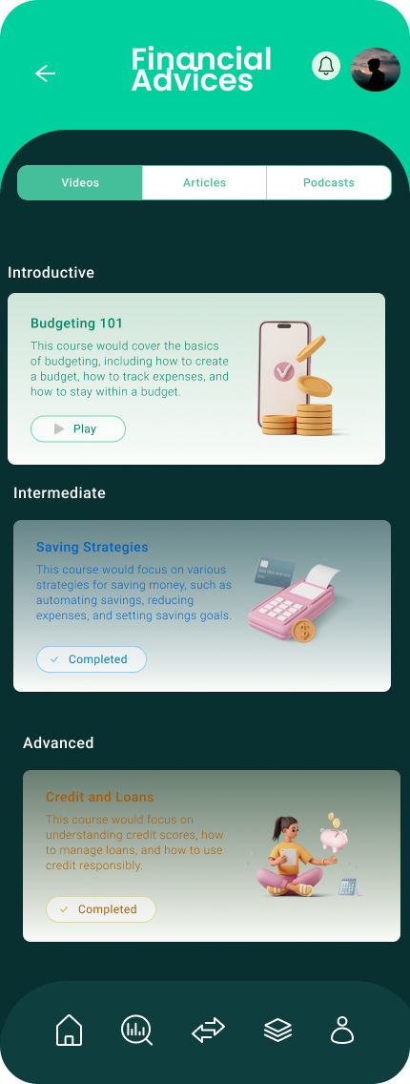 (Figma,2024a, Figma, 2024e)

**Financial Advices ( Videos) Screen 1**

When the user selects the Financial Advice option from the menu, they are redirected to a dedicated screen featuring educational content on financial management. Here, users can explore a variety of resources, including videos, articles, and podcasts, to enhance their financial literacy.

The Videos tab provides users with a collection of educational videos covering key financial topics such as budgeting, saving, investing, and debt management. Users can browse through top-rated videos, expert insights, and step-by-step guides to improve their financial decision-making.

There are videos available from beginner to advance catering for everyone needs.

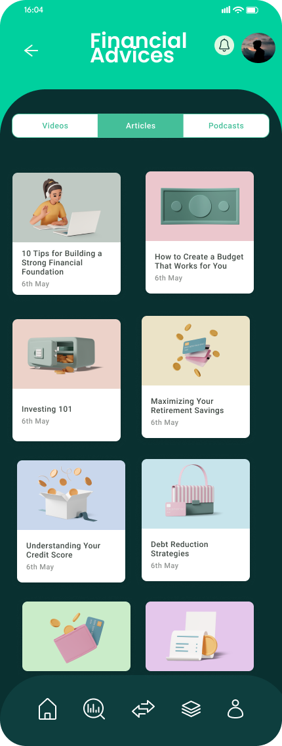 (Figma 2024a, Figma 2025e)

**Financial Advices ( Articles) Screen 2**

The user can switch screens by tapping articles and it will redirect them to the articles tab. In the Articles tab, users can read well-researched content on personal finance, money-saving strategies, and investment tips. Articles range from beginner-friendly guides to in-depth analyses, helping users gain valuable knowledge to achieve their financial goals. Users can select their preferred level to ensure the content matches their financial understanding.

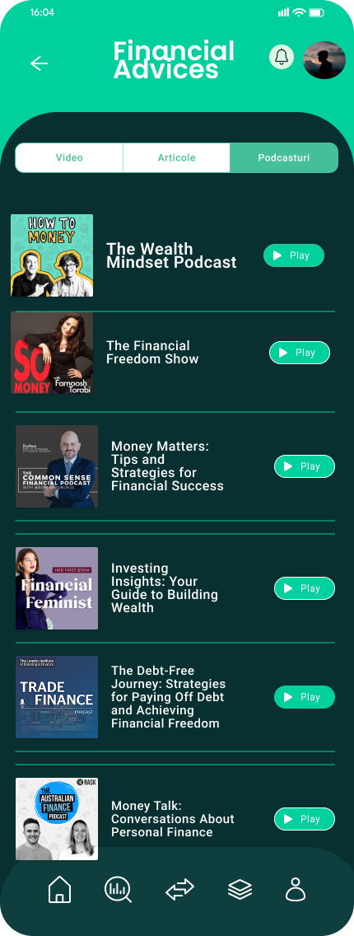 (Figma 2024a, Figma 2025e)

**Financial Advices ( Podcasts) Screen 3**

The user can switch screens by tapping podcasts and it will redirect them to the podcast screen. The Podcasts tab offers insightful discussions and expert opinions on financial trends, smart money habits, and economic updates. Users can listen to episodes on the go, making it easier to stay informed and improve their financial well-being. Each podcast is categorized by level, allowing users to choose beginner, intermediate, or advanced discussions based on their financial literacy.

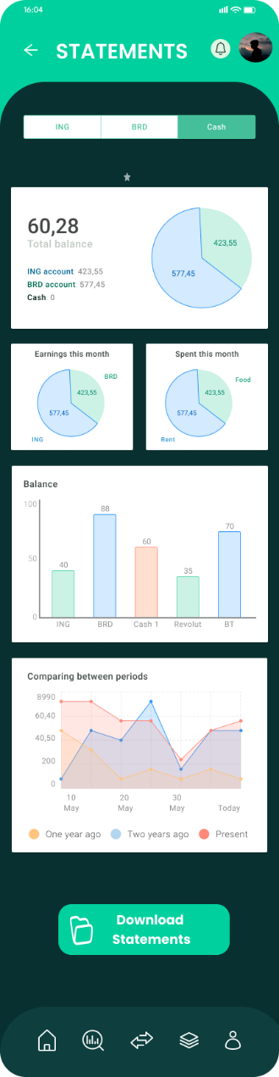 (Figma 2024a , Figma, 2024e)

**Statements Screen**

If users select the statements from the menu, they will be redirected to the Statements screen. Here they can view all types of graphs, bar charts and pie charts where they can see the analysis of categories, incomes and expenses. All the charts that are generated can be downloaded.

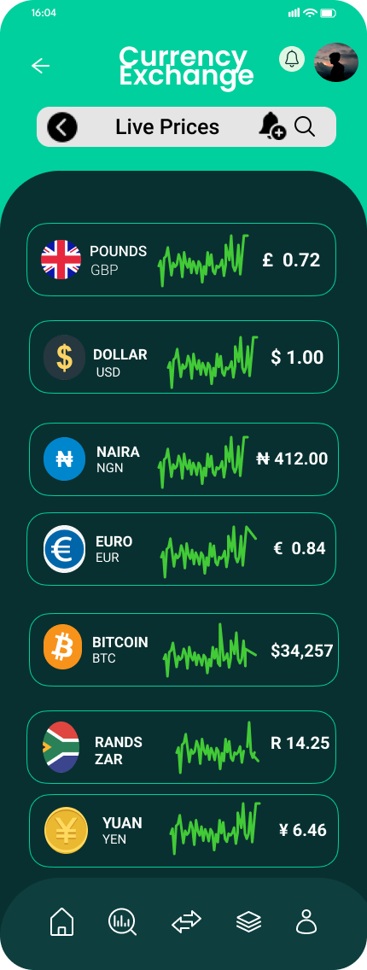 (Figma 2024a , Figma, 2024f)

**Currency Exchange Screen**

If users select the currency exchange from the menu, they will be redirected to the currency exchange screen. Users can view all currency and their rates. This is really helpful for users that deal with foreign exchanges or users who are travelling overseas.

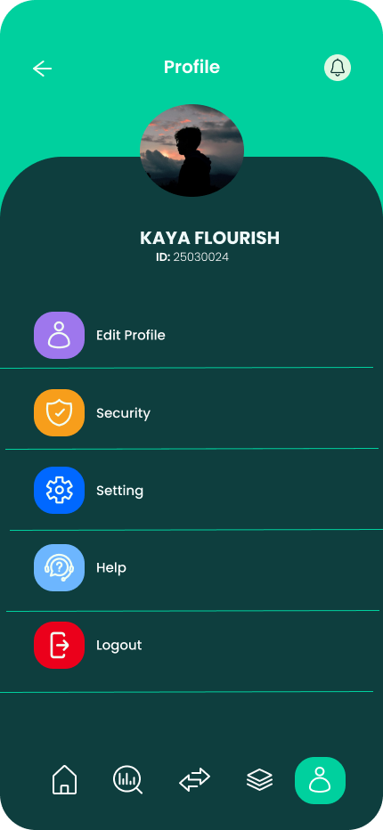 (Figma 2024a)

**Profile Screen**

The user can click on the navbar the person icon and will be redirected to this screen. Here the user can edit profile, security, setting , help and Logout.

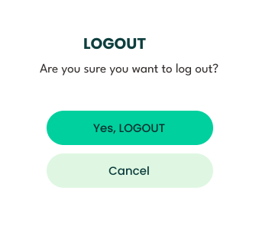(Figma,2025)

**Logout Message Screen**

If the user selects Logout ,this message will pop up , prompting the user if they are sure they want to log out.

(Figma,2025)

**Logout Screen**

This the screen that will be displayed after the user clicks the Logout button from the previous screen.

**Diagram – user navigation between app screens**

(Figma, 2025).

(Draw.io, 2023).

* **Project Plan (Gantt Chart)**

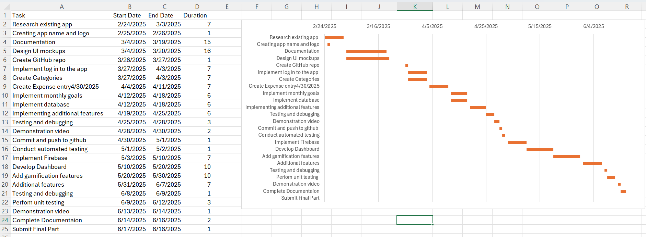

The project is structured into key phases, beginning with research and planning, followed by design, development, testing, and finalization.

1. Research & Planning (Feb 24 - Mar 4, 2025)
   * Research on existing apps to understand industry standards.
   * Creating the app name, logo, and initial documentation.
2. Design & Setup (Mar 4 - Apr 3, 2025)
   * UI mockups and GitHub repo creation.
   * Implementation of login functionality and category setup.
3. Core Development (Apr 4 - May 10, 2025)
   * Building essential features like expenses, monthly goals, and database setup.
   * Adding additional features, debugging, and testing.
4. Testing & Enhancements (May 10 - Jun 8, 2025)
   * Automated testing, Firebase integration, and dashboard development.
   * Incorporating gamification features and performing unit testing.
5. Finalization & Submission (Jun 8 - Jun 16, 2025)
   * Final testing, documentation completion, and demonstration video.
   * Submission of the final project.

Milestones include:

* Completion of research & design (March 4)
* Core functionality implementation (April 30)
* Testing and debugging phase (May 10)
* Final submission (June 16)

This structured approach ensures the app is developed systematically while allowing time for testing and improvements.

* **Conclusion**

Flourish is more than just a budgeting app—it’s a smart, user-friendly financial companion designed to empower users in managing their money effectively. By combining intuitive expense tracking, savings goal management, financial literacy resources, and engaging gamification elements, Flourish makes budgeting both simple and enjoyable. With features like multi-currency support, real-time notifications, a built-in calculator, and downloadable statements, users have all the tools they need to take control of their finances. Whether you're tracking daily expenses, setting ambitious savings goals, or improving financial habits, Flourish helps you stay on top of your budget and make informed financial decisions with ease. Start your journey to financial freedom today with Flourish! (OpenAI, 2024).

* **References**

Draw.io, 2023. *draw.io.* [online] Available at: <<https://app.diagrams.net/>> [Accessed 20 March 2025].

Figma, 2025. *Figma.* [online] Available at: <<https://www.figma.com/>>[Accessed 20 March 2025].

Figma, 2024a. *Finance management mobile app UI/UX kit for budget tracker financial prototype design* [online]. Available at: <https://www.figma.com/design/w4IMZKwGXE59PW0PZ3WbVo/Finance-Management-Mobile-App-UI-UX-Kit-for-Budget-Tracker-Financial-Prototype-Design-(Community)?node-id=7020-3430&p=f&t=qmiYzK2AYzz7HGIC-0> [Accessed 20 March 2025].

Figma, 2024b. *Budgetio (Community).* [online] Available at: <https://www.figma.com/design/hvGVzUcIOJ2OTfqY2xGk5B/Budgetio-(Community)?node-id=17-376&p=f&t=K83NBSsVblJtujpW-0> [Accessed 20 March 2025].

Figma, 2024c. *Responsive Calculator App (Community).* [online] Available at: <https://www.figma.com/design/tCiaShWAf8zrI6UutmbOxA/Responsive-Calculator-App-(Community)?node-id=0-1&p=f&t=h74bew1VHq3i4kAz-0> [Accessed 20 March 2025].

Figma, 2024d**.** *Rank Badge Design - Free (Community).* [online] Available at: <https://www.figma.com/design/hSsBEVaMSz42gLR5jqMzvg/Rank-Badge-Design---Free-(Community)?t=KUS8gvygPdtNBXvy-0> [Accessed 20 March 2025]

Figma, 2024e. *Budget Genius - Financial Budgeting App (Community).* [online] Available at: <https://www.figma.com/design/FUS5TzPEWuMC8AHLsh5XHX/Budget-Genius---financial-Budgeting-App-(Community)?node-id=25-1026&p=f&t=0CSAaJYiw4PkmutP-0> [Accessed 20 March 2025].

Figma, 2024f. *Currency Exchange (Community).* [online] Available at: <https://www.figma.com/design/UCS4GAEj1vrkIntsT0cdqc/currency-exchange-(Community)?node-id=0-1&p=f&t=F7Hgf0YWj6miP4CQ-0> [Accessed 20 March 2025].

OpenAI. 2024. Chat-GPT (Version 4). [Large language model]. Available at: <https://chat.openai.com> [Accessed: 11 March 2025].

**Annexure**

**Disclosure of AI Usage in my assessment**

**Section(s) within the assessment in which generative AI was used**

App Icon

**Name of AI tool(s) used**

OpenAI, ChatGPT

**Purpose/intention behind use**

Generating a logo

**Date(s) in which generative AI was used**

11 March 2025

**Screenshot**

**Disclosure of AI Usage in my assessment**

**Section(s) within the assessment in which generative AI was used**

Conclusion

**Name of AI tool(s) used**

OpenAI, ChatGPT

**Purpose/intention behind use**

Generating a conclusion

**Date(s) in which generative AI was used**

20 March 2025

**Screenshot**

